* **Cài máy ảo centos9, vmware, 20GB, 4GB**
* tạo **user root**, pass 1234,
* **tạo user thường, user bangthan2406**, pass 1234
* **đăng nhập vào máy ảo, mở terminal, ifconfig để xem ip**
* **ở máy thật**, mở putty, connect tới địa chỉ ip của máy ảo, đăng nhập vào user thường do user root ko đăng nhập được
* máy trường: tạo user mới, đăng nhập user mới rồi đăng nhập root
* su -, nhập pass 1234 để đăng nhập root
  + usermode -aG wheel bangthan2406: gán quyền user thường như root
  + exit, quay lại user thường
* su -, cần về user root để tải docker
* tải docker:
  + sudo dnf install -y dnf-utils device-mapper-persistent-data lvm2
  + sudo dnf config-manager --add-repo=https://download.docker.com/linux/centos/docker-ce.repo
  + sudo dnf install -y docker-ce docker-ce-cli containerd.io

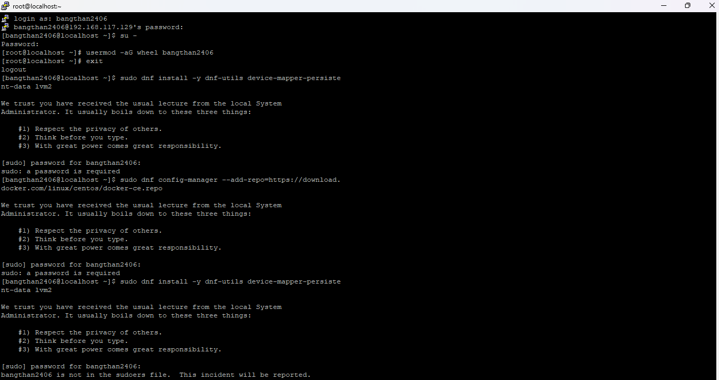

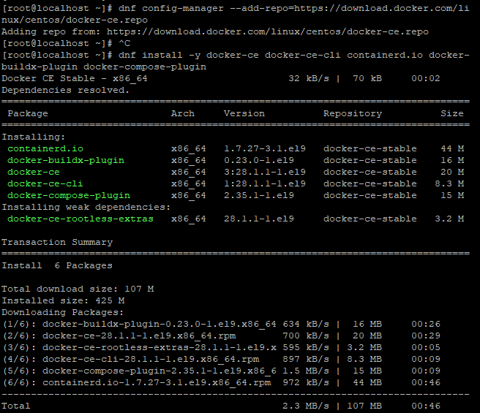

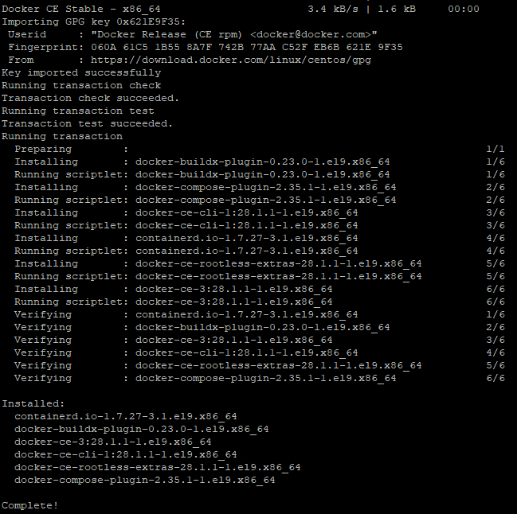

[bangthan2406@localhost ~]$ su -

Password:

[root@localhost ~]# sudo dnf install -y dnf-utils device-mapper-persistent-data lvm2

CentOS Stream 9 - BaseOS 608 kB/s | 8.7 MB 00:14

CentOS Stream 9 - AppStream 537 kB/s | 23 MB 00:43

CentOS Stream 9 - Extras packages 7.0 kB/s | 20 kB 00:02

Package device-mapper-persistent-data-1.1.0-1.el9.x86_64 is already installed.

Package lvm2-9:2.03.28-6.el9.x86_64 is already installed.

Dependencies resolved.

================================================================================

Package Architecture Version Repository Size

================================================================================

Installing:

yum-utils noarch 4.3.0-21.el9 baseos 40 k

Transaction Summary

================================================================================

Install 1 Package

Total download size: 40 k

Installed size: 23 k

Downloading Packages:

yum-utils-4.3.0-21.el9.noarch.rpm 90 kB/s | 40 kB 00:00

--------------------------------------------------------------------------------

Total 19 kB/s | 40 kB 00:02

CentOS Stream 9 - BaseOS 1.6 MB/s | 1.6 kB 00:00

Importing GPG key 0x8483C65D:

Userid : "CentOS (CentOS Official Signing Key) <security@centos.org>"

Fingerprint: 99DB 70FA E1D7 CE22 7FB6 4882 05B5 55B3 8483 C65D

From : /etc/pki/rpm-gpg/RPM-GPG-KEY-centosofficial

Key imported successfully

Running transaction check

Transaction check succeeded.

Running transaction test

Transaction test succeeded.

Running transaction

Preparing : 1/1

Installing : yum-utils-4.3.0-21.el9.noarch 1/1

Running scriptlet: yum-utils-4.3.0-21.el9.noarch 1/1

Verifying : yum-utils-4.3.0-21.el9.noarch 1/1

Installed:

yum-utils-4.3.0-21.el9.noarch

Complete!

[root@localhost ~]# ^C

[root@localhost ~]# dnf config-manager --add-repo=https://download.docker.com/li nux/centos/docker-ce.repo

Adding repo from: https://download.docker.com/linux/centos/docker-ce.repo

[root@localhost ~]# ^C

[root@localhost ~]# dnf install -y docker-ce docker-ce-cli containerd.io docker- buildx-plugin docker-compose-plugin

Docker CE Stable - x86_64 32 kB/s | 70 kB 00:02

Dependencies resolved.

================================================================================

Package Arch Version Repository Size

================================================================================

Installing:

containerd.io x86_64 1.7.27-3.1.el9 docker-ce-stable 44 M

docker-buildx-plugin x86_64 0.23.0-1.el9 docker-ce-stable 16 M

docker-ce x86_64 3:28.1.1-1.el9 docker-ce-stable 20 M

docker-ce-cli x86_64 1:28.1.1-1.el9 docker-ce-stable 8.3 M

docker-compose-plugin x86_64 2.35.1-1.el9 docker-ce-stable 15 M

Installing weak dependencies:

docker-ce-rootless-extras x86_64 28.1.1-1.el9 docker-ce-stable 3.2 M

Transaction Summary

================================================================================

Install 6 Packages

Total download size: 107 M

Installed size: 425 M

Downloading Packages:

(1/6): docker-buildx-plugin-0.23.0-1.el9.x86_64 634 kB/s | 16 MB 00:26

(2/6): docker-ce-28.1.1-1.el9.x86_64.rpm 700 kB/s | 20 MB 00:29

(3/6): docker-ce-rootless-extras-28.1.1-1.el9.x 595 kB/s | 3.2 MB 00:05

(4/6): docker-ce-cli-28.1.1-1.el9.x86_64.rpm 897 kB/s | 8.3 MB 00:09

(5/6): docker-compose-plugin-2.35.1-1.el9.x86_6 1.5 MB/s | 15 MB 00:09

(6/6): containerd.io-1.7.27-3.1.el9.x86_64.rpm 972 kB/s | 44 MB 00:46

--------------------------------------------------------------------------------

Total 2.3 MB/s | 107 MB 00:46

Docker CE Stable - x86_64 3.4 kB/s | 1.6 kB 00:00

Importing GPG key 0x621E9F35:

Userid : "Docker Release (CE rpm) <docker@docker.com>"

Fingerprint: 060A 61C5 1B55 8A7F 742B 77AA C52F EB6B 621E 9F35

From : https://download.docker.com/linux/centos/gpg

Key imported successfully

Running transaction check

Transaction check succeeded.

Running transaction test

Transaction test succeeded.

Running transaction

Preparing : 1/1

Installing : docker-buildx-plugin-0.23.0-1.el9.x86_64 1/6

Running scriptlet: docker-buildx-plugin-0.23.0-1.el9.x86_64 1/6

Installing : docker-compose-plugin-2.35.1-1.el9.x86_64 2/6

Running scriptlet: docker-compose-plugin-2.35.1-1.el9.x86_64 2/6

Installing : docker-ce-cli-1:28.1.1-1.el9.x86_64 3/6

Running scriptlet: docker-ce-cli-1:28.1.1-1.el9.x86_64 3/6

Installing : containerd.io-1.7.27-3.1.el9.x86_64 4/6

Running scriptlet: containerd.io-1.7.27-3.1.el9.x86_64 4/6

Installing : docker-ce-rootless-extras-28.1.1-1.el9.x86_64 5/6

Running scriptlet: docker-ce-rootless-extras-28.1.1-1.el9.x86_64 5/6

Installing : docker-ce-3:28.1.1-1.el9.x86_64 6/6

Running scriptlet: docker-ce-3:28.1.1-1.el9.x86_64 6/6

Verifying : containerd.io-1.7.27-3.1.el9.x86_64 1/6

Verifying : docker-buildx-plugin-0.23.0-1.el9.x86_64 2/6

Verifying : docker-ce-3:28.1.1-1.el9.x86_64 3/6

Verifying : docker-ce-cli-1:28.1.1-1.el9.x86_64 4/6

Verifying : docker-ce-rootless-extras-28.1.1-1.el9.x86_64 5/6

Verifying : docker-compose-plugin-2.35.1-1.el9.x86_64 6/6

Installed:

containerd.io-1.7.27-3.1.el9.x86_64

docker-buildx-plugin-0.23.0-1.el9.x86_64

docker-ce-3:28.1.1-1.el9.x86_64

docker-ce-cli-1:28.1.1-1.el9.x86_64

docker-ce-rootless-extras-28.1.1-1.el9.x86_64

docker-compose-plugin-2.35.1-1.el9.x86_64

Complete!

* **Xong bước cài docker, dùng docker –version kiểm tra thử**

[root@localhost ~]# docker --version Docker version 28.1.1, build 4eba377

[root@localhost ~]# docker run hello-world docker: Cannot connect to the Docker daemon at unix:///var/run/docker.sock. Is the docker daemon running? Run 'docker run --help' for more information [root@localhost ~]#

* **báo lỗi, dùng các lệnh sau:**
  + **Khởi động Docker daemon**: sudo systemctl start docker
  + **Để Docker tự khởi động khi hệ thống khởi động** (tùy chọn): sudo systemctl enable docker
  + **Kiểm tra lại trạng thái Docker**: sudo systemctl status docker

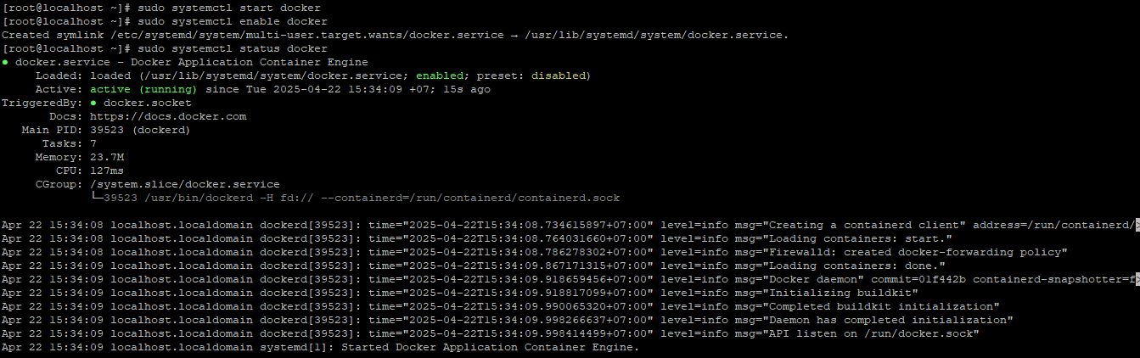- **dùng docker run hello-world kiểm tra:**

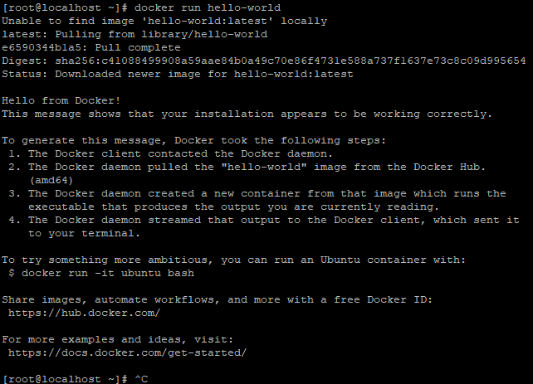

* **sửa file buildgradle của project**

plugins {

id 'java'

id 'war'

id 'maven-publish'

id 'org.hidetake.ssh' version '2.11.2'

}

group 'vn.edu.hcmuaf.fit'

version '1.0-SNAPSHOT'

repositories {

mavenCentral()

}

ext {

junitVersion = '5.11.0-M2'

}

sourceCompatibility = '17'

targetCompatibility = '17'

tasks.withType(JavaCompile) {

options.encoding = 'UTF-8'

}

dependencies {

compileOnly 'jakarta.servlet:jakarta.servlet-api:6.1.0'

testImplementation "org.junit.jupiter:junit-jupiter-api:${junitVersion}"

testRuntimeOnly "org.junit.jupiter:junit-jupiter-engine:${junitVersion}"

}

test {

useJUnitPlatform()

}

remotes {

host {

host = '192.168.117.129'

user = 'root'

password = '1234'

}

}

ssh.settings {

knownHosts = allowAnyHosts

}

task docker_app_start {

doLast {

println 'begin docker_app_start'

ssh.run {

session(remotes.host) {

execute 'docker stop tomcat9', ignoreError: true

execute 'docker run -it --rm -d ' +

'--name tomcat9 ' +

'-v /usr/deploy:/usr/local/tomcat/webapps ' +

'-p 80:8080 ' +

'tomcat:9.0&'

}

}

}

}

task docker_upload_file_to_server {

doLast {

println 'begin docker_upload_file_to_server'

ssh.run {

session(remotes.host) {

execute 'rm -rf /usr/deploy/lab.war'

execute 'rm -rf /usr/deploy/lab/'

execute 'rm -rf /usr/deploy/lab5-1/'

put from: "${project.projectDir}/build/libs/WebLab-1.0-SNAPSHOT.war",

into: "/usr/deploy/lab.war"

}

}

}

}

task docker_deploy {

dependsOn docker_app_start

dependsOn docker_upload_file_to_server

dependsOn build

tasks.getByName('docker_app_start').mustRunAfter docker_upload_file_to_server

}

* **chạy lệnh ở putty: mysql** :sudo docker run -it -d --name mysql -p 3306:3306 -e MYSQL_ROOT_PASSWORD=12345 mysql:latest
* **tomcat**:sudo docker run -it --rm -d --name tomcat10 -v /usr/deploy:/usr/local/tomcat/webapps -p 80:8080 tomcat:10.0

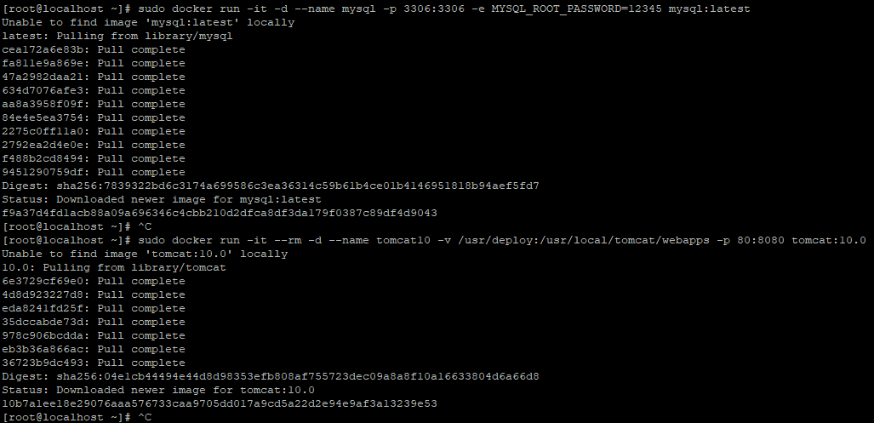

* **chạy lệnh:** sudo docker ps

  
- **truy cập địa chỉ IP của máy ảo trên browser của máy thật:**<http://192.168.117.129/>

**hiển thị trang 404 tức là ổn**  
[root@localhost ~]# ls -l /usr/deploy

total 0

-> CHƯA DEPLOY

- **vào project, mở terminal, chạy lệnh:**

gradlew build

gradlew docker_deploy -> báo lỗi, ko cho vào root

**ở putty (hiện đang là root)**, id bangthan2406: check tồn tại

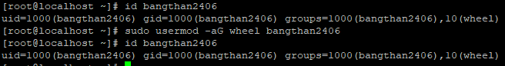

* **sudo mkdir -p /usr/deploy**
* **sudo chmod -R 777 /usr/deploy**
* **đổi lại user thành bangthan2406 (ở file gradle)**
* **chạy gradlew docker_deploy ở intelliJ cmd**

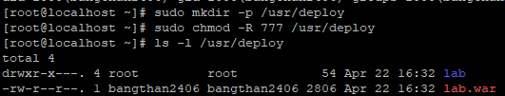

<http://192.168.117.129/lab/>

hiển thị hello world (trang jsp) là deploy thành công

project chính:

tạo file build.gradle:

plugins **{**

id 'java'

id 'war'

id 'maven-publish'

id "org.hidetake.ssh" version "2.11.2"

**}**

apply plugin: 'org.hidetake.ssh'

group = 'vn.edu.hcmuaf.fit'

version = '1.0-SNAPSHOT'

repositories **{**

mavenCentral()

**}**

dependencies **{**

providedCompile 'jakarta.servlet:jakarta.servlet-api:5.0.0'

implementation 'javax.servlet:javax.servlet-api:3.1.0'

implementation 'jakarta.servlet.jsp.jstl:jakarta.servlet.jsp.jstl-api:3.0.1'

implementation 'org.glassfish.web:jakarta.servlet.jsp.jstl:3.0.1'

implementation 'mysql:mysql-connector-java:8.0.33'

implementation 'org.jdbi:jdbi3-core:3.47.0'

implementation 'org.slf4j:slf4j-simple:1.7.36'

implementation 'com.sun.mail:jakarta.mail:2.0.1'

testImplementation 'org.junit.jupiter:junit-jupiter-api:5.9.2'

testRuntimeOnly 'org.junit.jupiter:junit-jupiter-engine:5.9.2'

**}**

java **{**

sourceCompatibility = JavaVersion.VERSION_11

targetCompatibility = JavaVersion.VERSION_11

**}**

remotes **{**

server **{**

host = '192.168.117.129'

user = 'bangthan2406'

password = '1234'

**}**

**}**

ssh.settings **{**

knownHosts = allowAnyHosts

**}**

task docker_app_start **{**

doLast **{**

println '>>> Khởi động container tomcat10 trên server...'

ssh.run **{**

session(remotes.server) **{**

execute 'docker stop tomcat10 || true'

execute 'docker rm tomcat10 || true'

execute 'docker run -d --name tomcat10 -v /usr/deploy:/usr/local/tomcat/webapps -p 80:8080 tomcat:10.0'

**}**

**}**

**}**

**}**

task docker_upload_file_to_server **{**

doLast **{**

println '>>> Upload file WAR lên máy ảo...'

ssh.run **{**

session(remotes.server) **{**

execute 'rm -f /usr/deploy/webbanthucung.war || true'

put from: "$**{**buildDir**}**/libs/$**{**rootProject.name**}**-1.0-SNAPSHOT.war", into: "/usr/deploy/webbanthucung.war"

**}**

**}**

**}**

**}**

task docker_deploy **{**

dependsOn build

dependsOn docker_upload_file_to_server

dependsOn docker_app_start

tasks.docker_app_start.mustRunAfter docker_upload_file_to_server

**}**

tasks.withType(JavaCompile).configureEach **{**

options.encoding = 'UTF-8'

**}**

tạo file setting.gradle:

rootProject.name = 'webbanthucung'

tải gradle về máy, mở cmd, chạy lệnh:

gradle clean build

project chuyển sang gradle, chạy lệnh:

gradle docker_deploy

nếu project lỗi thì kiểm tra lại tên file war trong gradle

nếu lỗi user không truy cập được docker, dùng lệnh sudo usermod -aG docker bangthan2406 (quyền root)

xóa libs trong webapp

lỗi vẫn đang là <http://192.168.117.129/webbanthucung/> hiển thị trang 500

cài mysql trên máy ảo: sudo dnf install <https://dev.mysql.com/get/mysql80-community-release-el9-1.noarch.rpm>

sudo dnf update

sudo dnf install mysql-server

sudo systemctl start mysqld

sudo systemctl enable mysqld

sudo systemctl status mysqld

sau khi cài xong, tạo database mới trên máy ảo rồi connect vào